İndüksiyon Motoru Eş Değer Devre Parametreleri

# Sorun Tanımı

Rüzgâr türbininde kullanılan indüksiyon motor 6-faz, asimetrik sargılara sahiptir. Aşağıdaki şekilde bu sargılar gösterilmiştir.



Bu motorun tork-hız (ya da tork-slip) karakteristiği Maxwell (transient çözüm) kullanılarak elde edilebilmektedir. Aynı zamanda, bu tork-hız karakteristiği, indüksiyon motorlarında aşağıda gösterilen eşdeğer devre parametreleri ile modellenebilmektedir.

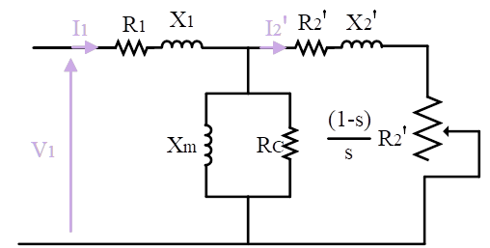

Bu eş değer devre elemanlarının, transient çözümden elde edilen grafikten doğrudan çekilmesi zor olmakla birlikte,

Bu motorun 6-faz hali için, Maxwell programında “transient” çözüm kullanılarak tork-hız (ya da tork-slip) grafiği elde edilebilmektedir.

Bu sargı

konfigürasyonu, iki tane 3-faz motor tek bir motor gövdesine takılmış gibi modellenebilir. Ayrıca, bu iki motor elektriksel olarak birbirinden ayrı ve aynı mekanik mile bağlıymış gibi düşünülebilir. Fakat, bu motorlar aynı mile bağlı olsa bile, ürettikleri gerilimlereler arasında 30-derece elektriksel fark oluşmaktadır.

. We can find the speed-torque characteristics of the induction motor using parametric sweep in transient model of Maxwell, but it does not give the equivalent circuit parameters. Since the deduction of the equivalent circuit parameters from the torque speed characteristics is difficult in transient model, we can use “rmxprt” model that gives directly these circuit parameters. However, these models are only valid for 3-phase induction machines. Therefore, we can convert our six-phase induction machine to combined three-phase induction machines. Firstly, we can divide our machine into two windings sequences that are ABC and XYZ, and then we can connect these two motors’ in parallel or series, as shown in Figure 2 and Figure 3.

Figure 2 Combined parallel connected 3-phase IM

Figure 3 Figure 2 Combined series connected 3-phase IM

Assume that these ABC and XYZ machines have no phase difference at their induced voltage. Since we have two machines in series or parallel, we can calculate different equivalent circuit parameters. While, in series connection, we achieve twice of ABC or XYZ parameters in the combined three-phase machine, in parallel connection, we obtain the half of ABC or XYZ parameters.

Further, converting 6-phase motor to 3-phase motor changes some circuit parameters because we have actually 30-deree phase difference at the induced voltage. It means that actually distribution factor become involved. The equivalent circuit diagram of a phase of an induction motor is shown in Figure 4.



Figure 4 The equivalent circuit of IMs

where,

= Stator winding resistance

= Stator winding leakage reactance

= Resistance-representing core losses

= Magnetizing reactance

= Rotor winding resistance referred to the primary

= Rotor winding reactance referred to the primary

## Resistance Calculation in Induction Motor

Winding resistances can be calculated by where, is length, is area, and is resistivity which changes with temperature .

Since mean length of the windings become twice in series connection, which means that we achieve twice of the phase resistance. Besides, in parallel connection, the copper is become twice, which means that we achieve half of the phase resistance.

|  |  |  |
| --- | --- | --- |
| Combined 3-phase series model  (Per phase equivalent) | Combined 3-phase parallel model  (Per phase equivalent) | Six-phase model  (Per phase equivalent) |
|  |  |  |
|  |  |  |

## Stator Rotor Turns Ratio

and are winding factors for the stator and rotor respectively. In the combined three-phase and six-phase models, and changes via 30-degree distribution factor.

where q is the number of slots, is angular slot pitch, and is pole pitch.

In our case, winding factor changes with correction factor 0.9659 of . ()

|  |  |  |
| --- | --- | --- |
| Combined 3-phase series model  (Per phase equivalent) | Combined 3-phase parallel model  (Per phase equivalent) | Six-phase model  (Per phase equivalent) |
| 0.9659 | 0.9659 |  |
|  |  |  |

.

## Cage Rotor Parameters

A cage rotor is equivalent to a secondary winding having Q2 conductors or bars connected in pairs a pole pitch apart so that there are Q2/p phases.

where is the rotor phase current referred to primary (stator), m is # of phase

The current per bar is

In deriving this equation, the rotor is assumed to have Q2/p phases each with p/2 turns and the pitch factor is taken as unity. Let Rber = resistance of one bar including the end ring. Then,

So, the rotor resistance referred in primary side changes with .

|  |  |  |
| --- | --- | --- |
| Combined 3-phase series model  (Per phase equivalent) | Combined 3-phase parallel model  (Per phase equivalent) | Six-phase model  (Per phase equivalent) |
|  |  |  |

## Leakage Reactance

For a coil of N turns surrounding a magnetic circuit of reluctance R, the flux per ampere is

where is the permeance of the flux path. Now

where A is the effective area and L is the length of the flux path. The leakage inductance of the coil is

Henries

Then, for the combined system leakage reactance’s are the same. However, rotor reactance referred to primary side changes with .

|  |  |  |
| --- | --- | --- |
| Combined 3-phase series model  (Per phase equivalent) | Combined 3-phase parallel model  (Per phase equivalent) | Six-phase model  (Per phase equivalent) |
|  |  |  |

## Magnetizing Reactance

This reactance in the equivalent circuit determines the current that is drawn by the motor to establish the pole flux ϕ in the magnetic circuit.

We have already shown that for a 3-phase winding of turns per phase and p-poles, the amplitude of the resultant MMF is

where, i is the rms current.

|  |  |  |
| --- | --- | --- |
| Combined 3-phase series model  (Per phase equivalent) | Combined 3-phase parallel model  (Per phase equivalent) | Six-phase model  (Per phase equivalent) |
|  |  |  |

# Solidity of the Equivalent Circuit Parameters

The equivalent circuit of IMs actually changes with respect to slip, but IMs are working the slip near “s=0”. Rmxprt model gives the stator leakage reactance, rotor resistance, and rotor leakage reactance with respect to varying slip as can be seen in Figure 5.

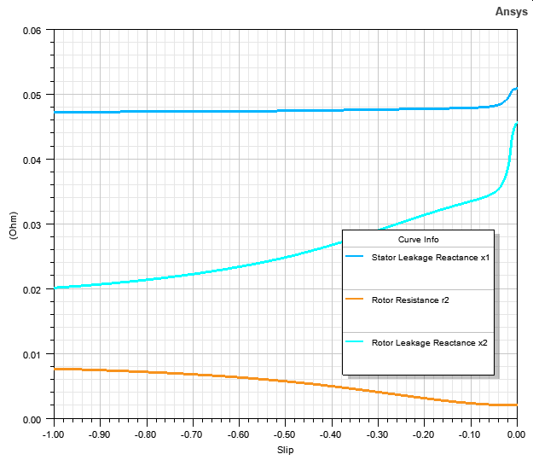

Figure 5 Rmxprt results of equivalent circuit parameters

However, using only the equivalent circuit parameters in “s=0” gives a realistic torque values the slip close to 0. The comparison of varying (Rmxprt model) and constant (equivalent circuit model) equivalent circuit parameters are given Figure 6. The values are separated by moving away from “s=0”, but these operations are already not expected. Therefore, equivalent circuit model can be used in modelling of IMs.



Figure 6 Comparison of Torque for equivalent circuit parameters and Rmxprt model

# Comparison of 6-phase Transient Model and 3-phase Combined Rmxprt Model

In 3-phase combined Rmxprt model, we can connect two 3-phase IMs in parallel or series, but we cannot excite them separately. Therefore, we have some differences in Torque-slip characteristics as can be seen in Figure 7.



Figure 7 Comparison of Torque Characteristics for Transient and Rmxprt model

While Rmxprt model gives the rated torque at 1206.25 RPM, Transient model gives it at 1206.55.

# Enhanced Equivalent Circuit Parameters

The equivalent circuit parameters are updated by considering the electrical differences between the phases. The comparison of torque characteristics of all models is given in Figure 8.



Figure 8 Comparison of Torque Characteristics for all models

While Transient model gives the rated torque at 1206.55, enhanced equivalent circuit model gives it 1206.7.

# Circuit Parameters

|  |  |  |
| --- | --- | --- |
| **Parameter** | **3-Phase Combined Parallel Model**  **(for combined two IMs)** | **3-Phase Enhanced**  **Model (for single IM)** |
|  |  |  |
|  |  |  |
|  |  |  |
|  |  |  |
|  |  |  |
|  |  |  |
| Stator Phase Current |  | **2016A** |
| Magnetizing Current |  | - |
| Core Loss Current |  | **10.15A** |
| Power Factor |  | 0.8781 |
| Slip |  | -0.0055779 |
| Shaft Speed |  | 1206.6935 RPM |
| Number of Poles |  | 6 |
| Inertia | 242.28 kg.m^2 |  |

# Simulink Model

In the Simulink, built-in induction motor model exists, and it takes the equivalent circuit parameters except core loss resistance. Therefore, we can update our equivalent circuit as given in Figure 9.



Figure 9 Updated equivalent circuit of IMs

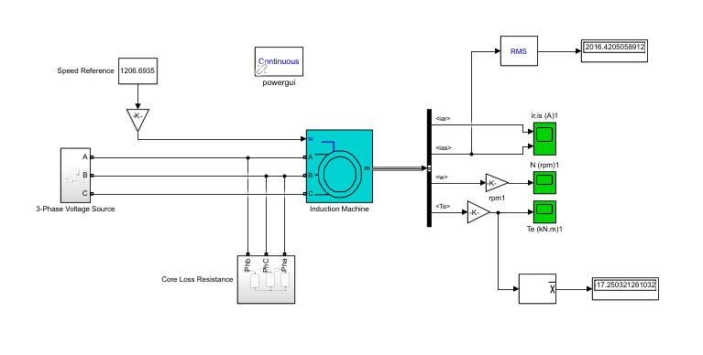

Figure 10 Simulink Model Of the IM

## Blocks and Parameters in the Simulink

|  |
| --- |
| Core Losses |

|  |
| --- |
| Induction Machine |

|  |
| --- |
| System Parameters |

# DlgSilent Model